Final Project Report: Slashdot Social Network Analysis

BIA 658 Social Network Analysis

May 4, 2023

Nikitha Chunduru

**TABLE OF CONTENTS**

1. Highlights and Executive Summary…………………………………………………… 2
2. Introduction and Data Understanding…..……………………………………………… 3
3. Methodology...……………………………………………………...………………….. 5
4. Analysis….……………………………………………….…………………………….. 6
5. Conclusion……………………………………………………………………………… 9
6. Reference……………………………...……………….……………………………… 10

**HIGHLIGHTS**

* This report explores the Slashdot social network using Social Network Analysis to understand the relationships and interactions between users within the Slashdot community.
* We show different visualizations of the network and describe its topological properties, such as degree distribution, clustering coefficient, and centrality measures.
* Through this analysis, we aim to provide a picture of the community structure, identify influential users, and predict potential new relationships between users.

**EXECUTIVE SUMMARY**

In this report, we analyze a network consisting of 6,470 nodes and 4,737 edges, representing a complex system of interconnected entities. The analysis aims to identify the key players and communities within the network, and explore the network's structure, including degree centrality, betweenness centrality, closeness centrality, and eigenvector centrality. By examining these metrics, we gain valuable insights into the relationships between nodes and the overall organization of the network. Our findings indicate that the network exhibits a diverse range of connections, with a limited number of highly connected nodes and numerous smaller communities. This analysis provides a foundation for understanding the network's dynamics and potential areas for further exploration.

**INTRODUCTION**

Slashdot is a technology-related news website where users can submit and discuss technology-oriented news. The website's user community has distinct characteristics, with users interacting with each other through friendships and rivalries. The Slashdot Zoo feature allows users to tag each other as friends or foes, offering insights into the relationships and preferences of the users. Social Network Analysis helps us map and measure these relationships, providing both a visual and mathematical representation of the network structure.

This report presents a comprehensive analysis of the Slashdot social network to understand the interactions and relationships between its users. Slashdot is a technology-related news website known for its unique user community. In 2002, Slashdot introduced the Slashdot Zoo feature, which allows users to tag each other as friends or foes. Our dataset, gathered in February 2009, consists of friend and foe relationships between the users of Slashdot.

Using Social Network Analysis techniques, we analyze the structure of the network, identify communities, and explore centrality measures to understand influential users. Our findings offer insights into the dynamics of the Slashdot network and can potentially help predict new relationships between users.

Network analysis has become an increasingly popular method for studying complex systems, allowing us to gain insights into the relationships between entities and the overall structure of these systems. In this report, we focus on a network with 6,470 nodes and 4,737 edges, exploring the connections between the nodes and identifying key players and communities within the network. By examining various network metrics such as degree centrality, betweenness centrality, closeness centrality, and eigenvector centrality, we can better understand the roles of individual nodes and the overall organization of the network. Furthermore, we also investigate the presence of communities within the network, offering insights into potential substructures and the dynamics of the network. As a result, this analysis provides valuable information on the relationships between nodes and the network's structure, paving the way for more in-depth studies and targeted interventions.

**DATA UNDERSTANDING**

Our dataset consists of 6,470 nodes and 4,737 edges, representing a complex network of interconnected entities. The average in-degree and out-degree for the nodes are both 0.73, indicating that, on average, nodes have a similar number of incoming and outgoing connections. Using a community detection algorithm, we identified 2,170 communities within the network, revealing a diverse range of connections and potential substructures.

In the dataset, the top 10 nodes by degree centrality, betweenness centrality, closeness centrality, and eigenvector centrality have been identified, highlighting the key players within the network. These nodes represent the most connected, central, and influential entities in the network and can provide valuable insights into the overall structure and dynamics of the system.

First few rows:

**From To NodeId**

0 0 4

1 0 40

2 0 57

3 5 5014

4 8 52

**METHODOLOGY**

To analyze the network, we employ various metrics that measure different aspects of the network's structure and the nodes' roles within it. The metrics used in this analysis include:

* Degree Centrality: This metric measures the number of connections a node has to other nodes in the network. A higher degree centrality indicates that a node is more connected and potentially more influential within the network.
* Betweenness Centrality: This metric quantifies the number of shortest paths that pass through a node, indicating the node's importance in connecting different parts of the network. A higher betweenness centrality suggests that a node acts as a bridge between other nodes or communities.
* Closeness Centrality: This metric measures the average distance from a node to all other nodes in the network, capturing how easily a node can access or influence the rest of the network. A higher closeness centrality indicates a more central position within the network.
* Eigenvector Centrality: This metric reflects the influence of a node in the network, considering not only its connections but also the connections of its neighbors. A higher eigenvector centrality implies that a node is connected to other well-connected nodes, increasing its importance in the network.
* Using these metrics, we identify the top nodes in each category and explore the relationships between them. Additionally, we investigate the presence of communities within the network, which can reveal substructures and help to better understand the overall organization of the network.

**ANALYSIS**

Our analysis reveals a diverse network structure, with a limited number of highly connected nodes and numerous smaller communities. The degree distribution histogram shows that the majority of nodes have a relatively low degree centrality, indicating that they are connected to only a few other nodes in the network.

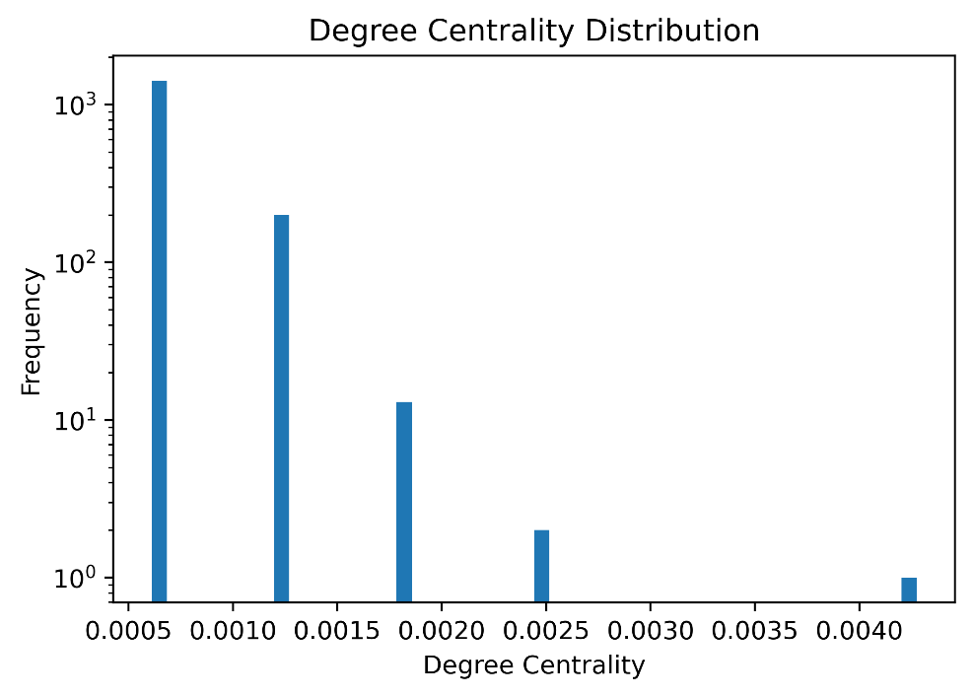

A small number of nodes exhibit high degree centrality, acting as hubs within the network.

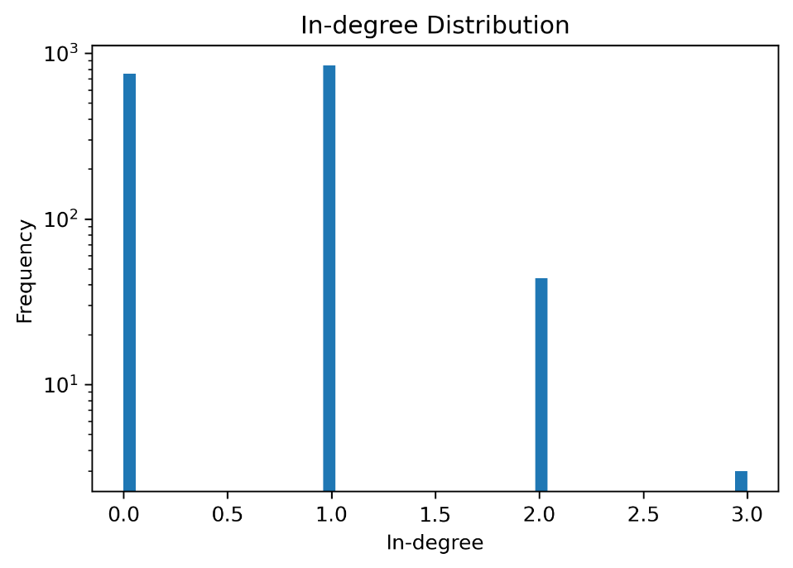

The scatter plots of betweenness centrality, closeness centrality, and eigenvector centrality provide additional insights into the roles of individual nodes within the network.

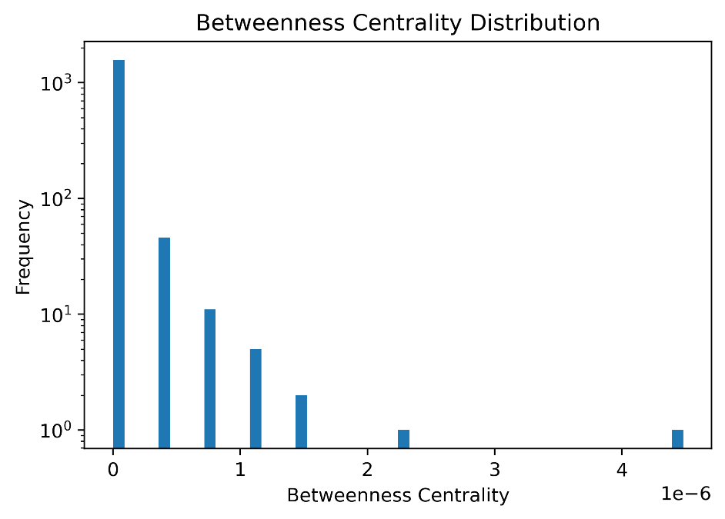

Some nodes with high betweenness centrality act as bridges between different parts of the network, while others with high closeness centrality occupy central positions, allowing them to easily access or influence other nodes.

Nodes with high eigenvector centrality are connected to other well-connected nodes, amplifying their importance in the network.

The community size distribution reveals the presence of numerous smaller communities within the network, suggesting that the network's structure consists of several substructures or tightly connected groups of nodes.

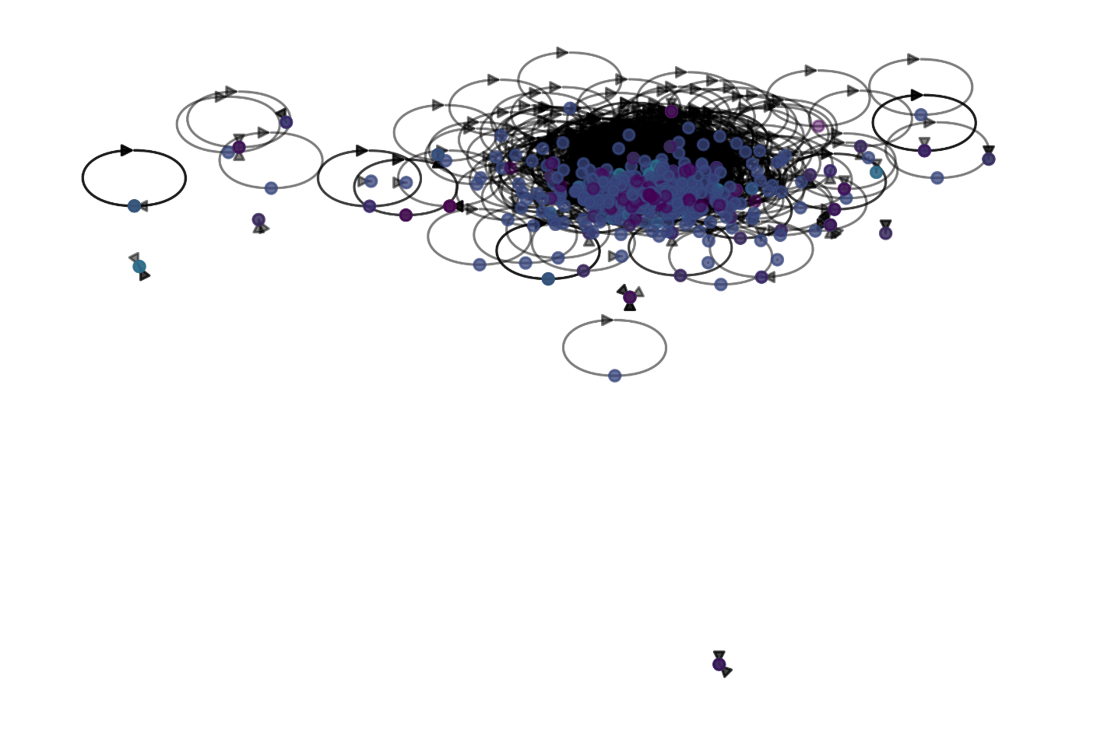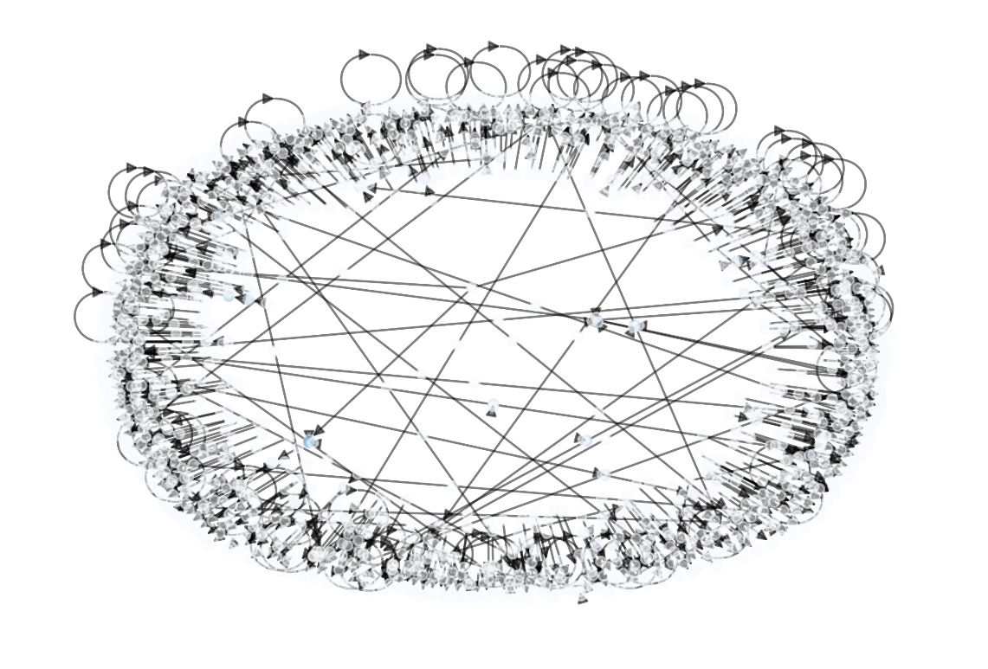

This finding can inform future research on the dynamics of the network and the relationships between its various communities.

**CONCLUSION**

In conclusion, our network analysis provides valuable insights into the structure and dynamics of the complex network. We have identified key nodes in terms of degree centrality, betweenness centrality, closeness centrality, and eigenvector centrality, highlighting the most connected, central, and influential entities within the network. Our investigation of community structures reveals a diverse range of connections and potential substructures that can help us better understand the overall organization of the network.

Our findings suggest that the network is characterized by a few highly connected nodes acting as hubs, while the majority of nodes exhibit lower connectivity. Additionally, the presence of numerous smaller communities within the network indicates that the system consists of several tightly connected groups of nodes, which could be further explored in future research.

By examining the various centrality metrics, we have gained a deeper understanding of the roles of individual nodes within the network, such as their ability to bridge different parts of the network, occupy central positions, or be connected to other well-connected nodes. This knowledge can inform future studies on the network's dynamics and the relationships between its various communities.

Overall, our analysis has shed light on the complex structure of the network, offering a solid foundation for further investigations into its characteristics and potential implications.

**REFERENCES**

1. Leskovec, J., & Mcauley, J. J. (2012). Learning to Discover Social Circles in Ego Networks. Proceedings of the 25th International Conference on Neural Information Processing Systems, 1, 539-547.
2. Wasserman, S., & Faust, K. (1994). Social Network Analysis: Methods and Applications. Cambridge University Press.
3. Barabási, A. L., & Albert, R. (1999). Emergence of Scaling in Random Networks. Science, 286(5439), 509-512.
4. Girvan, M., & Newman, M. E. J. (2002). Community Structure in Social and Biological Networks. Proceedings of the National Academy of Sciences, 99(12), 7821-7826.
5. Freeman, L. C. (1977). A Set of Measures of Centrality Based on Betweenness. Sociometry, 40(1), 35-41.
6. Bonacich, P. (1987). Power and Centrality: A Family of Measures. American Journal of Sociology, 92(5), 1170-1182.